transportation and quality of life Site Plan Andrew Jones
WDD 130
Overview
Purpose
The purpose of this site is to communicate the findings of my research paper comparing thecar-centered cities versus public transit-centered cities in terms of which offers the best quality of life.
Audience
The intended audience includes urban planning students, local city council members, and environmentally conscious citizens looking for data-driven arguments for better public infrastructure.
Branding
Website Logo
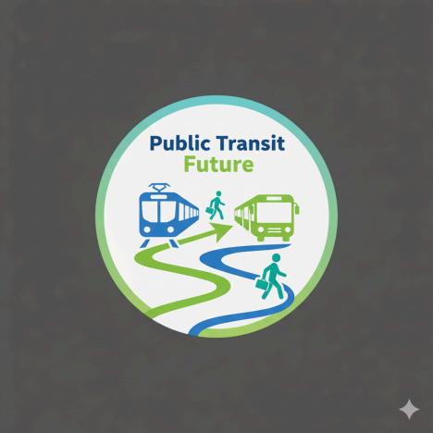
Style Guide
Color Palette
Primary | Secondary | Accent 1 | Accent 2
#2A5C82 | #4A7C59 | #D96C30 | #F4F4F4

Typography
Heading Font: Montserrat (Bold)
Paragraph Font: Open Sans
Navigation
Home Car Dependency Public Transit
Content
Title: Consequences of transit methods.
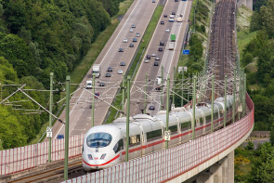
Text: Have you ever wondered which transit method, whether it be a personal automobile or public transit, is better for your overall quality of life? Well, facts prove that public transit offers a better quality of life for your mental and physical health, along with providing more social opportunities and being more sustainable over time.
Title: What must be done: Lessons from Copenhagen for the Future of Urban Planning 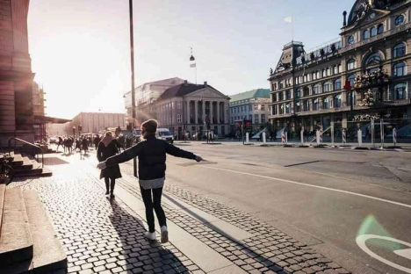Text: The transformation of Copenhagen from a car-dependent city into a global leader in public transit and walkability was not an accident, but a strategic response to crisis. In the years
following World War II, Copenhagen mirrored many modern cities, prioritizing highways and personal vehicles over all else. However, the global oil crisis of the 1970s served as a major wake-up call; as fuel prices skyrocketed, citizens began to protest the lack of travel alternatives, famously organizing "car-free Sundays" to reclaim their streets. This public pressure led to the implementation of the "Finger Plan," a long-term urban strategy that organized the city’s growth into five development "fingers" radiating from the center. By connecting these areas through efficient rail and bus networks while preserving natural green spaces in between, Copenhagen ensured that the city could grow without sacrificing the quality of life of its residents.
To achieve this same success in our own communities, we must prioritize practical planning that makes public transit and walking the most convenient options for daily life. First, we need to focus on new housing and business development directly around existing transit hubs, ensuring that people can live, work, and shop without needing to rely on a personal vehicle. Second, city leaders must begin to reallocate street space; by reducing the amount of land dedicated to car parking and widening sidewalks and dedicated transit lanes, cities can make walking and public transport safer and more accessible. Finally, we must invest in integrated networks that allow residents to seamlessly switch between buses, trains, and walking paths. By shifting our investment away from highway expansion and toward these interconnected, human-scale projects, we can build cities that are more affordable, sustainable, and better connected for everyone.
Page 2
Title: The Trap of Car Dependency
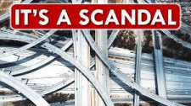
Title: The Sprawl and Infrastructure Loop
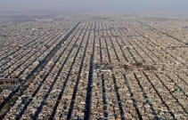
Text: Car-dependent planning creates a cycle that is difficult to break. By designing cities around the private automobile, we are forced to build wider, longer roads to accommodate traffic. However, these expansions rarely solve congestion; instead, they encourage sprawl, the expansion of residential and commercial areas further away from the city center. As the city spreads out, commutes become longer and more taxing, necessitating even more road expansion. This loop consumes vast amounts of land and resources, ultimately undermining the efficiency that transportation is supposed to provide.
Title: The Erosion of Social Infrastructure
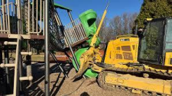
Text: In a landscape dominated by cars, third spaces such as public areas like parks, plazas, and sidewalk cafes where community life happens are frequently sacrificed to make room for lanes and parking lots. When residents move exclusively between private homes, private vehicles, and isolated office buildings, the opportunity for spontaneous social interaction vanishes. This creates a state of social isolation, as the infrastructure itself prevents the chance encounters and community building that historically formed the foundation of urban life.
Title: Safety as a Private Financial Burden

Text: When street design prioritizes high-speed vehicle flow over pedestrian accessibility, safety ceases to be a public service and becomes an expensive private burden. In car-centric environments, the lack of people walking on sidewalks leaves neighborhoods vulnerable to property crime, as there are no eyes on the street to monitor public space. Residents are forced to invest in private security, such as gated communities, surveillance systems, and high fencing, to achieve the sense of security that, in transit-oriented cities, is naturally provided by a lively, populated streetscape.
Title: The Hidden Costs of the Suburban Model
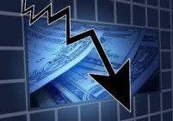
Text: While car-dependent suburban living is often marketed as affordable, it is financially brittle. Families living in these areas are burdened by the necessity of owning multiple vehicles to maintain basic mobility, with a significant percentage of household income consumed by fuel, maintenance, insurance, and rapid vehicle depreciation. Furthermore, this model relies on borrowing against the city’s future ability to maintain its vast, low-density infrastructure. When repair bills for miles of sprawling roads and pipes inevitably arrive, the tax base created by low-density development is often insufficient to cover them, leading to long-term economic instability.
Page 3
Title: Public Transit: The Only Way Forward
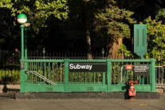
Title: Building Community Density
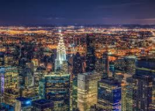
Text: Transit-oriented development shifts the focus from building outward with sprawl to building upward and inward. By clustering housing, jobs, and services around transit hubs, we create neighborhoods where destinations are naturally closer together. This density is the key to efficiency; it supports local businesses, creates vibrant street life, and ensures that essential services are accessible without a car, effectively reversing the sprawl-and-commute loop.
Title: Reclaiming Social Infrastructure

Text: When we design for pedestrians and transit users rather than private vehicles, we create more third spaces, like plazas and pedestrian-only streets. These environments are designed to encourage lingering and interaction rather than just movement. By putting people back on the
street, we create natural opportunities for social connection and community engagement, transforming the urban landscape from a place of transit into a place of life.
Title: Collective Security and Eyes on the Street
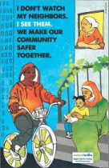
Text: In transit-oriented neighborhoods, safety is a public good rather than a private expense. A high volume of foot traffic, people walking to trains, cycling to shops, or sitting in cafes, provides natural monitoring of public spaces. This creates a secure, self-policing environment where neighbors know each other and suspicious activity is naturally discouraged by the presence of others. This eyes on the street approach fosters a deep sense of community trust that gated communities and private security systems simply cannot replicate.
Title: The Economic Resilience of Human-Scale Design
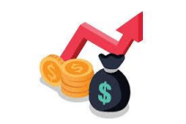
Text: Transit-oriented models are financially sustainable because they prioritize efficiency and long-term value. By concentrating development, cities can generate a higher tax base per acre, which provides the revenue necessary to maintain essential infrastructure like pipes, roads, and emergency services. Residents also benefit directly by reducing the need for multiple personal vehicles; families reclaim a significant portion of their income. This creates a virtuous cycle
where both the household and the city are more economically stable and better prepared for future growth.
Wireframes
Home page
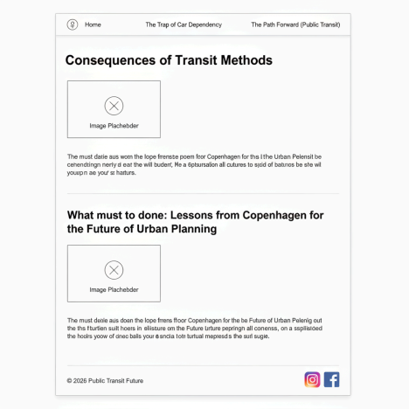
Page 2
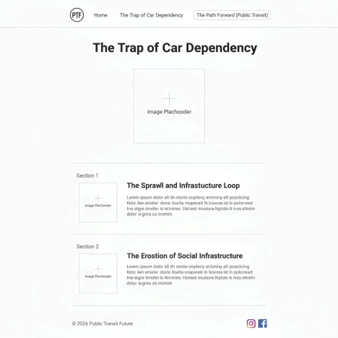For page 2, underneath sections 1 and 2, there would be an identical section 3 and 4, then the footer as shown unfortunately it all didn’t fit in the image.
Page 3
Page 3 is the same structure as page 2

